CALL backs

# .Onload Function

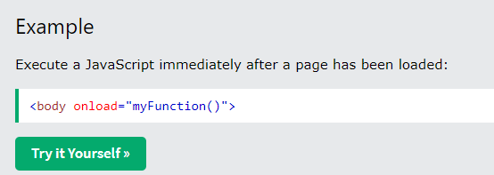

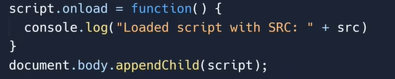

# .onerror function

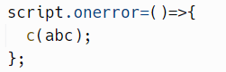

Any function inside

# Synchronous and Asynchronous Programming

## Example of synchronous programming

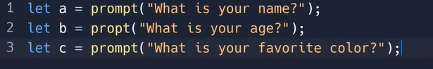

The commands will be executed line by line and won’t execute again

## Example of Asynchronous programming

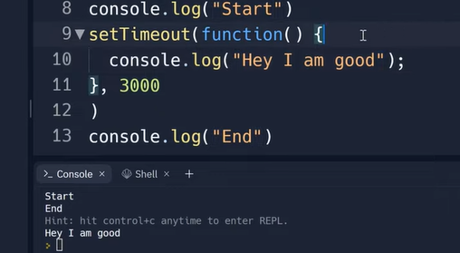

# Callback functions

Call back function Is a fucntion wihtin a function

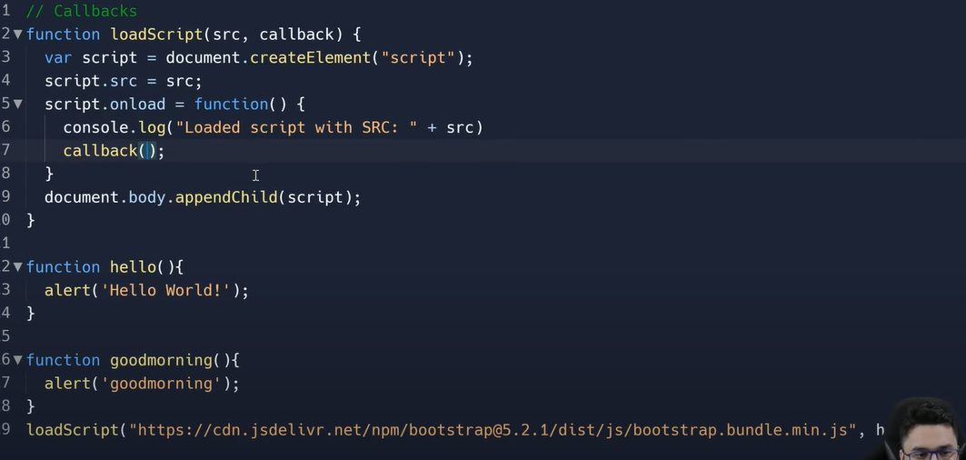

### 

//**callback function ko as a variable pass krein ge hu**

### And when callbackfunciton has an argument as well

Callback-based style of async programming

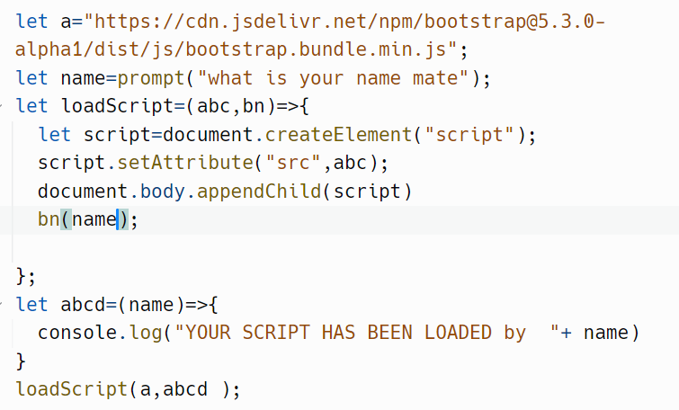

//two three things to keep in mind

1. ***Jo call back function hai upar load script mein us ka koi bhi name ho sakta hai lkin neechay bhi fir wohi name rkhna hai with (); tocall that function***
2. ***Ager argument pass kr rhy hain tu call back function mein bhi same argument he pass krein gay***
3. ***Or upar call back funciton jo bnata hai us mein kuch bhi likhnay ke zaruray nahi hai***

#### FOR BETTER UNDERSTANDING

## SAME PROBLEM WITH ONERROR AND ONLOAD

//or remember ke humne jo yeh function likhay hai usse style sheet ya jsscript add ho jai gi lkin aager load krny pr error aa rha hai tu us ke lie yeh error handling humuse kr rheinhain

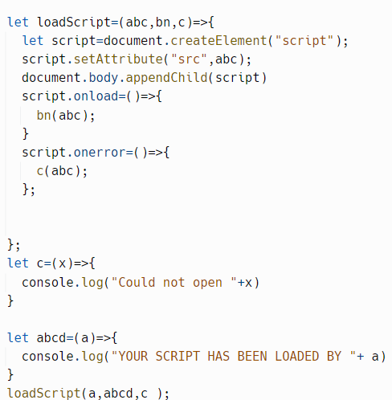

### HARRY”S CODE

### 

### Another example with style sheet

### [Introduction to Callbacks | JavaScript Tutorial in Hindi #52](https://www.youtube.com/embed/IJlGpI6l92U?feature=oembed)

## REPLIT LINK

https://replit.com/@Hasnain150/callBacks30#script.js